What Is Cardio Yoga? And 5 Reasons To Add It To Your Routine

Yoga enthusiasts everywhere will agree that this slower paced, meditation centered workout is not for the faint of heart. Yep, it’s much harder than you think!
Yoga can help manage stress, relieve pain and tension throughout the body, and is mostly noted for improving strength, flexibility, and balance.
But, despite its benefits, there’s no denying that yoga comes up short in regards to building endurance.

Therefore, even die-hard yogis would need to turn to other activities like running, cycling, or swimming if they want to really push their cardiovascular system and gain endurance.

Then there’s the issue of the elephant in the room, or on the yoga mat, as well...sometimes yoga can be great, but sometimes it can be a little boring if you’re the type of person who just likes to get moving!

So, if you’re that person, someone who needs to build endurance, wants to build cardiovascular strength, likes yoga but also wants to spice things up, then cardio yoga may be just what the doctor ordered!

Let’s discover exactly what cardio yoga is, and why you should add it to your current workout routine!

What Is Cardio Yoga?

Cardio yoga is just what it sounds like, yoga moves combined with cardiovascular exercise.

While typical yoga workouts are a bit slower paced, focusing more on getting each pose correct, concentrated breathing, body flow, and even meditation, cardio yoga speeds up both the movements and the time between each movement to further engage your muscles and give you a great cardiovascular workout.

Kajuan Douglas, founder of Merge New York, gives a great description: “timing is key with these types of flow, instead of moving like you’re taking a leisurely stroll in the park, move in your yoga practice like you have someplace to be five minutes ago. Create a tempo that means business.”

Cardio yoga forces your lungs, heart, and other muscles to work hard throughout the entire workout, pushing your body to its limits.

And, some cardio yoga workouts even incorporate other “non-yoga” movements as well, like running and jumping, to amp up the intensity even more.

But, as great as all of that sounds, why should you actually consider adding this type of exercise to your current routine?

5 Reasons You Should Add It To Add It To Your Routine

1- Girls (and guys) Just Wanna Have Fun

One common woe of yoga is that it’s just not fun, or it’s too boring for some folks to stay motivated to continue doing it, despite its many benefits.

Cardio yoga solves that, taking the beneficial yoga movements and increasing the tempo (often with music).

While some argue that adding music and increasing the tempo of yoga takes away from the spiritual experience many seek through this type of exercise, most find it helps with breathing, endurance, and just makes the entire workout much more fun!

And, those in the “music makes everything better” camp also point out that working out in an upbeat manner to the flow of music keeps you motivated both during the exercise to get a better workout, and it keeps you coming back for more!

2- Weight Loss

Now of course, like with any type of exercise, working out isn’t the only method for weight loss. And, to shed pounds in a healthy manner you need to clean up your nutrition as well, but cardio yoga can definitely aid in your efforts to shrink your waistline!

Cardio yoga, as opposed to traditional yoga, increases your caloric burn significantly by incorporating more intense cardiovascular movements.

3- Killer Workout

No, not the Mike Myers type of killer, but possibly just as heart racing as watching that creepy dude stalk Jamie Lee Curtis!

All jokes aside though, cardio yoga is designed to push your heart and lungs to their max in order to build endurance.

Many yoga moves and poses can be difficult in and of themselves, but when done at an accelerated tempo, the continual movements involved in this fusion of cardio and yoga will get your muscles burning, your heart pumping, and your body sweating to give you a killer workout!

4- No Equipment Required

One huge perk of cardio yoga is that you can do it practically anywhere!

You won’t need weights, equipment, or even much space to get a great workout with cardio yoga.

Ideally a yoga mat would be a help, but you technically don’t even need that. You just need enough space for your body to go through the movements (again, think faster paced yoga movements performed within the space of a typical yoga mat, not full-court basketball), and you’re all set!

5- To Your Health

Fusing cardio with yoga gives you the best of both worlds when it comes to your health.

The typical yoga benefits of stress relief, balance, muscle strength, and flexibility can still be reaped through practicing cardio yoga.

And, with the added cardio element, you can also:

- Lower your blood pressure
- Reduce pain
- Regulate blood sugar
- Boost your mood
- Strengthen your immune system
- Improve the health of your heart
- Boost brain health by improving the flow of oxygen to the brain
- Improve breathing by strengthening your lungs
- Increase weight loss through extra calorie burn

Sample Workouts

Okay, we’ve listed the details and pros of cardio yoga, but what does an actual workout really look like?

How about a few samples, you say? Ask and you shall receive!

Check out these 3 cardio yoga flows below, and keep in mind the increased tempo that we’ve mentioned throughout this article.

Cardio Yoga Flow #1 (by NYC based yogi: Beth Cooke)

1. Start in Downward Facing Dog.
2. Inhale, extend your right leg up into Three Legged Dog.
3. Exhale and step your right foot to your right thumb, dial your left heel down toward the mat.
4. Inhale, rise up to Warrior II.
5. Exhale, settle into a clear Warrior II shape.
6. Inhale, straighten your front leg as you reach your right arm up and tilt back into a Reverse Triangle.
7. Exhale, cartwheel your hands down into a Low Lunge.
8. Inhale, lift your right arm for a Low Lunge Twist.
9. Exhale, pour your weight into your left hand as you stack your right ankle on top of your left for a Left Side Plank (to modify, drop to your knees).
10. Inhale, take your right bicep along your right ear and bump your hips higher for an Extended Side Plank.
11. Exhale, move right hand down to Regular Plank, then press back into Downward Facing Dog.
12. Inhale, to either an Upward Facing Dog or Modified Upward Facing Dog.
13. Exhale, press back into Downward Facing Dog.

Repeat the entire sequence on your left side.

Cardio Yoga Flow #2 (by Yoga Instructor Claire Grieve)

1. Start in Downward Facing Dog.
2. Exhale, move to Plank.
3. Inhale, pull your right knee to your nose.
4. Exhale, push back into One-Legged Plank.
5. Inhale, bend your elbows back into One-Legged Chaturanga.
6. Exhale, push up into One-Legged Plank.
7. Inhale, move your hips back into One-Legged Downward Facing Dog.
8. Exhale, plant your foot for Downward Facing Dog.

Repeat the entire sequence on the left side.

Cardio Yoga Flow #3 (Sun Salutation series from Ashtanga Vinyasa Yoga)

1. Samasthiti. Start standing up straight with your feet together and weight evenly distributed. Your shoulders should be rolled back and your hands should be hanging by your side with your chin parallel to the ground.
2. Urdhva hastasana. Inhale and bend your knees slightly, raising your arms over your head. Bring your palms together and look at your thumbs.
3. Uttanasana. Exhale and straighten your legs. Bend forward from the hips and bring your hands down. Relax your neck.
4. Urdvah uttanasana. Inhale and lengthen your spine, looking forward and opening your shoulders.
5. Chaturanga dandasana. Exhale and jump or step your feet back. Bend your elbows and keep them tucked into your sides. Lower your body. You may either keep your knees off the floor, or modify the exercise by bringing your knees to the ground.
6. Urdhva mukha svanasana. Inhale and point your toes away from your body. Lift your chest while your knees stay off the ground. Open your shoulders and look up to the sky.
7. Adho mukha svanasana. Exhale and tuck your toes under, lifting your hips and bringing your shoulders down. Look at your navel. You may wish to stay in this position for up to five deep breaths.
8. Urdhva uttanasana. Inhale and jump or step your feet together between your hands, lengthen the spine and look to the front while opening your shoulders (same as step 4).
9. Uttanasana. Exhale and lower the crown of your head toward the ground and relax your neck (same as step 3).
10. Urdhva hastasana. Inhale and bend your knees, raising your arms over your head and bringing your palms together while looking at your thumbs (same as step 2).
11. Samasthiti. Exhale and straighten your legs, bringing your arms to your sides (same as step 1).

Complete this sequence at a relatively quick pace and repeat it for 20 minutes with no rest in between to keep your heart rate elevated.

60 Second Metabolism Boost

My friend a Canadian mother of three just uncovered a HUGE weight loss discovery...
Her simple “Over 30 Female Hormone Solution” is literally transforming the lives of thousands of women over 30 who suffer from menopausal and other female hormone related imbalances.

Debbie Anderson discovered this over 30 female hormone solution from the healthiest and longest living habitants of a remote island in the world.

And once her hormones were in balance, she was finally able to flip the switch on her metabolism

...and she lost 55 pounds in the shortest time possible WITHOUT exercising (she was recovering from an injury) or giving up her favorite high-carb foods.

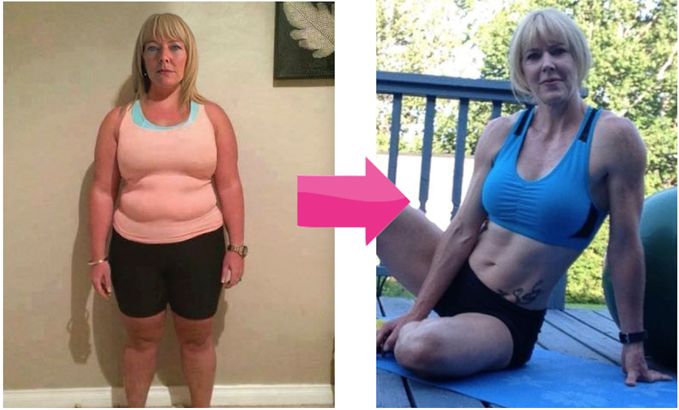

Do this Simple 30 Hormone Solution to Flip the Switch on Your Metabolism

References:

- https://www.fitday.com/fitness-articles/fitness/everything-you-need-to-know-about-cardio-yoga.html
- https://www.healthline.com/nutrition/cardio-yoga
- https://bulldogonline.com/blog/5-reasons-to-add-a-new-cardio-yoga-flow-to-your-routine/
- https://www.wellandgood.com/cardio-yoga/
- https://www.hopkinsmedicine.org/health/wellness-and-prevention/9-benefits-of-yoga
- https://www.shape.com/fitness/trends/fast-paced-yoga-with-music-trend
- https://www.corepoweryoga.com/blog/benefits-adding-cardio-your-yoga-practice
- https://pranayoga.co.in/asana/surya-namaskar-a-ashtanga-yoga/

