7 Strategies To Help You Make Health A Priority

Making the decision to make your health a top priority in your life isn’t that difficult.

However, sticking to that decision as you go about your day to day life is where the difficulties often arise.

You can have the best, and healthiest, intentions, but sometimes troubles, temptations, and just plain old life gets in the way.

So, how do you keep your health from being pushed to the bottom of the priority list?

How do you “keep on keeping on” through the ebb and flow of everyday living, let alone when things get downright crazy. Because let’s face it, everyone’s got a little bit of crazy in their life.

If you’re accustomed to shelving your health and wellness goals, struggling to truly make you and your health a priority, you’re not alone.

But, thankfully there are a few solutions, tips, and strategies to help you make, and keep, your health a top priority!!

1- Mindset

Sometimes priority is all about mindset. And, I’m actually not referring to motivation or inspiration here at all.

As adults, many of us spend our days caring for and catering to the needs of others: family, children, employees, friends, colleagues.

It is so easy to put yourself on the back burner. So much so that it can even feel odd to really and truly put yourself first.

In fact, putting yourself first, making your health a priority, can seem out of place.

Change that mindset.

Give yourself permission to put yourself and your health at the top of the list.

Truly take a moment to evaluate your health, your goals, and the reason you are desiring to make healthier choices in the first place.

You are worthy of health.

But, sometimes we just need to affirm this. Sometimes we need this reminder.

Maybe you enjoy your life spent caring for others. That’s fine, just remember that you can’t truly pour from an empty cup.

Change your mindset. You don’t have to put your health on the backburner. Give yourself permission to make the needed changes and build the needed habits to make your health a priority.

This shift in mindset can make all the difference when it comes to keeping health a center stage priority in your life.

2- Set Realistic Goals

This is difficult for me...and I’m not alone.
Some folks just have a ‘Rome absolutely can be built in a day’ mindset. And, no matter how optimistic this sounds, the bottom line is that it isn’t realistic.

So, what’s an extremist to do?

No matter how bad you want that marathon finisher’s medal, you will do more harm than good to your health (mental, physical, and emotional) by biting off more than you can realistically chew. In other words, a 4 week couch to 26.2 plan is not a good plan.

No matter your goals, be realistic. If the term ‘realistic’ is greek to you, do a simple google search to find your center.

If you want to cut out processed sugar completely from your diet, that’s an incredible, healthy, and perfect goal.

But, if you’ve been living off of cookies, cakes, and candies for the last 20 years, cutting it out cold turkey may result in a complete crash and burn (not to mention actual sugar withdrawal symptoms).

A more realistic goal may be to track the amount of processed sugar you are consuming and gradually cut down the number of grams of sugar you consume over the next 3-4 weeks until you’ve cut it out completely.

Watch your success in seeing that overall number decrease week after week.

Enjoy the good and healthy way that your body feels as you are choosing healthier foods in place of unhealthy food choices.

Or, what about weight loss?

If you are seeking to lose 75 pounds, keeping that number alone as your goal can get discouraging due to the length of time that will be required to reach it.

Instead, set smaller weight loss goals on the way to that 75 pound mark. And, choose other goals along the way that don’t deal with an actual number but include small, healthy habits.

You can even set realistic goals regarding your fitness level.

If that marathon is in your sights, set smaller mileage goals along the way to avoid feeling discouraged on your journey to 26.2 miles.

3- Do What You Love

This is a hard and fast rule for me. If you don’t love what you’re doing, you will not stick with it.

Now, this is tempered with some common sense, of course. But, life’s just too dang short to be doing something day in and day out that you absolutely loathe.

But, what about “no pain, no gain?” Or, what about perseverance?

No worries, I’m not omitting any of that. So, hear me out.

I hate aerobics classes. Hate...like seriously loathe. But, I love to run. I enjoy lacing up, going outside, breathing the fresh air and feeling the sun on my skin as I sweat buckets and pound the pavement.

The foam rolling and epsom salt baths are proof that there’s pain in my game.

The love of pushing myself to achieve greater distances in less time screams perseverance.

So no, I’m not talking about giving up completely. But, I am talking about eradicating the idea of health and wellness that says you can only eat rabbit food to be healthy, and if you hate salads you might as well just forget about eating healthy altogether.

So what if you hate spinach, maybe you’re more of a kale kinda guy? You won’t know until you try.

So what if you hate burpees to the point that you’d rather skip a workout than do them. Modify! Do some push ups and squats instead. Just don’t throw the baby out with the bathwater.

You’re far more likely to exercise on a regular basis, making this a part of your life that is sustainable, if you enjoy doing it. Love to roller skate? Awesome, ditch that run and lace up your skates instead, and enjoy moving your body!

You’re far more likely to continue eating healthy if you find a variety of healthy, nutritious foods that you enjoy. So, try new foods, and seek out other ways to cook and season those healthy foods.

I’m sure you get the point, but I just can’t stress it enough...life is short, enjoy the journey!

4- Tackle Stress

Stress will derail your life. (Read that punctuation aloud: period)

Stress will not only keep you from a healthy lifestyle, it will rob you of health completely.

No one is immune from stress, and if you do not deal with it, you could be letting this sleeping bear counteract all of the good and healthy habits you are trying to instill in your life.

Seeking to lose weight? Stress can make it more difficult to shed pounds due to hormonal shifts that can occur when stress and anxiety is not dealt with.

Stress can wreak havoc on your sleep patterns thus hindering your health and making it more difficult to make healthy decisions throughout the day.

Your efforts in the gym and the kitchen can be for naught if stress is reigning in your life.

So then, how do you keep stress from overtaking your life and wreaking havoc on your health?

Exercise
Chances are you’re already incorporating ways to move your body more if you’re seeking to make health a priority. But, the act of exercise can be a stress reliever in and of itself.

So, don’t skip those workouts.

And, if you’re feeling overwhelmed, take an extra walk around the block to clear your head for a moment. You’ll get in some movement and destress in the process.

Deep Breathing
Deep breathing can both dissipate stress in the moment and can keep your body in a greater state of calm in general.

I would recommend practicing deep or mindful breathing each and every morning upon waking, and use the practice amidst stressful situations as well.

Seek to inhale through your nose, filling your belly (as opposed to your chest) as you breathe in deeply.

Exhale through your mouth, feeling your stomach tighten as you release your breath.

Journal
Take a few moments to write down your thoughts on paper. This can serve as a way to release any tension or emotions that are building or have built up causing you stress.

Gratitude
Keep a daily list of things you are grateful for. Thinking on the positives in your life can change your entire outlook and help you live in a greater state of calm, thus relieving stress.

Socialize
Talk to a friend. Having someone to talk to is completely underrated.

There is a strong temptation in our society to keep things inside. Strength is often seen in bearing things alone. And, I’m here to tell you that this is a lie.

The old saying rings true, “no man is an island.” (John Donne)

Spend time with loved ones, family, and friends. Relax. Enjoy. Destress!

Self Care
Do something relaxing, something that you enjoy.

Take a long bath. Watch your favorite tv show. Read a book. Go for a drive and listen to some music. Immerse yourself in a hobby. Take a walk in nature.

Find some time to take a step back from your everyday life, taking a moment to just unwind.

5- Create Habits

We like to be inspired. We like to be motivated. But, when the rubber meets the road, we won’t always feel inspired or motivated.

There will be days when you just don’t feel like putting your health first. And, while a day off now and then isn’t bad (you’ve heard of cheat meals, right?), consecutive days “off” can snowball.

So, you that you won’t always feel like making your health a priority...no matter your why. But, what’s the solution?

I love this quote by Octavia Butler, and I think the wisdom here holds the answer to the question posed above: “First forget inspiration. Habit is more dependable. Habit will sustain you whether you’re inspired or not.”

And really...that’s it.

If you create healthy habits, you’ll be able to make your health a priority day in and day out, whether you feel like it or not.

When life throws you curveballs, when sleep evades you, when donuts dare you to jump ship on your goals...habits and routines can be powerful tools to keep you on track.

It is said that it takes an average of 66 days for a new behavior to become automatic. So, grab your calendar and set a goal: 66 days. That’s roughly 3 months.

I realize there’s info that reports a lesser timeframe for making something a habit, but I love that word “automatic.”

Commit to 3 months, red pen in hand ready to cross off each day that you’ve made YOUR health a priority. Establish routines, and commit to sticking with those healthy routines for 3 months.

Then, when those curveballs come, “...habit will sustain you whether you’re inspired or not.”

6- Journal

Keeping a journal can have multiple benefits when it comes to your health. And, we’re not just talking about typical “dear diary” entries here either.

Journalize your journey.

- Keep track of your measurements- weight, body fat percentages, measurements in inches (waist, hips, etc).

- Keep track of your progress- how you feel after your workouts, any improvements in time or weight during cardio or strength training workout sessions, how you feel after eating certain meals and amounts of food

- Keep track of your successes- Include every single high on your journey and look back on these on days that present as troublesome.

- Keep track of your struggles- Life is life. You will have struggles, but acknowledging them and then seeing how you’ve overcome them will be incredibly beneficial when evaluating what works and what doesn’t along your journey.

- Keep track of your emotions- Journalize how you feel on good days and bad. You’ll essentially be granting yourself permission to let go of what could potentially hold you back. This can also help to relieve stress, which we’ve seen can hinder your health and your journey to achieving a healthier you.

The bottom line...journaling can paint a picture that you may not be able to see while in the midst of your daily grind. It can help you take a step back and better evaluate problems, and it can help you see progress that can seem otherwise veiled.

And, being able to clearly see this picture can help to keep you motivated on your journey to a healthier you.

7- Put Temptation In Time Out

Yep, you read that correctly...time out.

Time out is often used as a disciplinary measure with children to grant both space and time.
Space away from the problem or issue, and time to reevaluate choices and thought processes.

So, why not use that strategy when temptation comes calling?

If you’re seeking to make health a priority, you won’t be immune from the temptation to derail your goals with a late night junk food binging session, or a warm cozy bed in the morning tempting you to skip your workout.

So, try some space when it comes to wanting to hit snooze on your alarm...seriously...space.

Place your alarm clock or phone across the room, thus forcing yourself to get out of bed to turn it off.

Then, since you’re already out of bed, give yourself some time on your feet to reevaluate your decisions. Remind yourself of why you’re choosing to make your health a priority.

Between both the space and time principles here, you’ll be much less likely to crawl back into bed and skip your planned workout session.
What about those food cravings turned temptations though?

Put those temptations in time out as well.

What if you’re enjoying a little break from your hectic day by watching a few Friends reruns before bed, but you can’t seem to shake the urge to grab a snack, despite the fact that you’re not even hungry and you’ve been on track with your goals up to this point?

First, make sure you’ve got some space between yourself and the fridge (or pantry). Don’t go browsing through your cupboards out of boredom.

Second, time. Try setting a timer for 10 or 15 minutes when cravings strike. Then, use that time to think about your goals, your health, and evaluate whether or not you’re truly hungry. And, have a glass of water while you’re waiting/thinking/evaluating.

After this set amount of time has elapsed, if you’ve had a glass of water (or sparkling water which can stave off hunger), and you still truly feel hungry, opt for a healthy choice instead of junk food.

Start today, making your health a priority!

This breakfast drink eliminates constipation? (not coffee)

Most people think coffee helps flush your bowels…

But the fact is it only works for about 1 in 3 people.

Yet there’s one unusual nutrient you can ADD to your coffee, tea, OJ, or even oatmeal or smoothie…

Which triples your chances of enjoying a “perfect poop” right after breakfast.

Try this simple tweak to triple your chances of pooping every morning

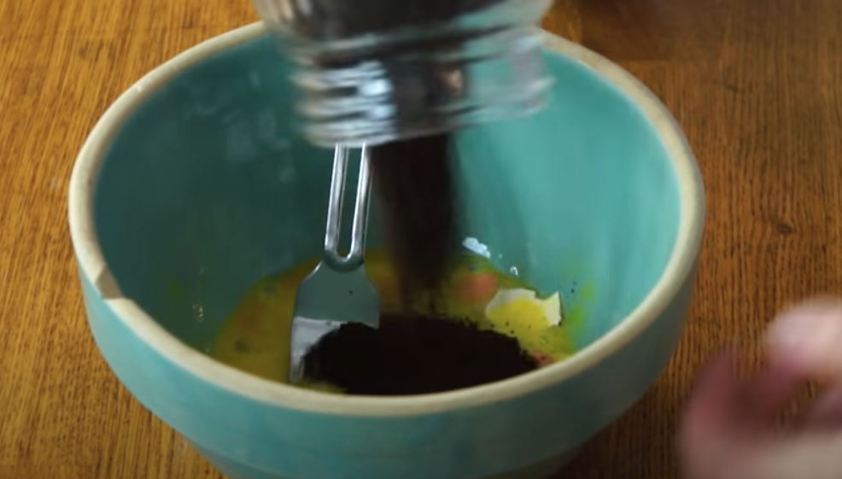

References:

- https://artofhealthyliving.com/6-ways-to-make-your-health-a-priority/
- https://www.cooksmarts.com/articles/tips-to-get-healthy/
- https://www.corporatewellnessmagazine.com/article/five-tips-to-prioritize-health
- https://www.westchesterhealth.com/blog/9-simple-ways-to-make-your-health-a-priority-in-the-new-year/
- https://www.healthline.com/health/how-long-does-it-take-to-form-a-habit#takeaway

