10 Varieties Of Bread That Won’t Wreck Your Weight Loss

Carbs are bad. Bread is bad. I’ll never be able to give up bread, so I’ll never be able to lose weight. I give up. Right?

Wrong!!

The notion that you can never have bread if you want to lose weight is surely coming to a Mythbusters episode ‘near’ you.

Why?

Because not all carbs are bad. Not all bread is bad, and you don’t have to ditch it completely to have success in your weight loss endeavors.

In fact, there’s a whole grocery list full of bread options that won’t sabotage your weight loss efforts!

So, grab your pen and grocery list pad and read on…

1- Ezekiel Bread (Sprouted Whole Grain Bread)

No sugar, great protein content, and satiating...a triple win when it comes to aiding in weight loss efforts.

Ezekiel bread is made from organic, sprouted whole grains like wheat, millet, barley, spelt, soybeans, and lentils. And, it is full of essential vitamins and minerals that are more easily absorbed and used by the body due to the way the bread is made/processed.

It can be found in many supermarkets and most all health food stores, though it is important to note that this choice, due to the wheat, barley, and spelt, is not gluten free.

2- Sourdough Bread

Sourdough breads can be made with both white and whole wheat flour, though the whole wheat varieties contain a greater amount of iron, fiber, and other nutrients.

This type of bread is made through a fermentation process where the flour and natural yeasts cause the bread to rise.

The actual baking process begins as the mixture of flour and water is left to ferment for several days prior to baking.

This fermentation process is what causes the generally notable difference in taste in sourdough breads.

And, the fermentation process also creates both pre and probiotics, groups of healthy bacteria that aid in digestion and support a healthy gut, both of which are beneficial to achieving and maintaining a healthy weight.

Another benefit? Sourdough bread has a low glycemic index, meaning it is less likely to cause spikes in blood sugar.

3- 100% Whole Wheat Bread

Made from unrefined flour, 100% whole wheat bread is high in protein, fat, vitamins, and minerals. This is largely due to the fact that whole wheat breads allow the wheat grain/kernel to remain intact, whereas refined grains are mainly processed.

Coming in lower on the glycemic index than your average white bread, whole wheat breads will keep you feeling full for a longer period of time.

Whole grains are also associated with a decreased risk of type 2 diabetes, cancer, heart disease, and other chronic illnesses.

4- Oat Bread

Oat bread, generally made from oats, whole wheat flour, yeast, water, and salt, is a great option if you’re seeking to lose weight.

Oats are already a great healthy food choice due to their rich fiber and nutrient content, but they are also very satiating as they take longer to digest.

Oats have been found to lower cholesterol levels, reduce blood pressure, and regulate blood sugar, making oat bread not only a great choice for weight loss but for your health in general.

5- Gluten Free Bread

For those who are gluten intolerant or have celiac disease, thankfully gluten free bread options are becoming increasingly available in most supermarkets.

Gluten-free bread options are often made using one of many flour choices such as: brown rice flour, corn flour, coconut or almond flour, or tapioca flour.

While gluten free bread options can be high in added sugars, there are some healthy options to look for that won’t derail your weight loss efforts and achievements, namely those varieties made from almond and coconut flour.

6- Rye Bread

Rye bread tends to be both darker and more dense than wheat bread.

It typically falls into two categories: made with rye flour alone, or made with both rye and wheat flour. Rye bread made from 100% whole grain sprouted rye flour is considered to be the healthiest option.

Rye bread is most noted for its ability to lower the body’s insulin responses.

One study concluded that those who ate only whole grain rye bread released much less insulin than those who ate white bread. And, other studies have shown rye bread even makes you feel full longer, thus aiding in weight loss efforts.

7- Brown Rice Bread

Brown rice bread is a gluten free option that is weight loss friendly and loaded with essential vitamins and minerals such as: thiamin, calcium, magnesium, and potassium.

It is high in both fiber and protein making it a great, filling bread choice.

Brown rice bread falls into the “healthy whole grains” category which makes it associated with a decreased risk of common health conditions like heart disease, some cancers, diabetes, and obesity when incorporated into a healthy diet.

8- Flax Bread

Often dubbed the healthiest bread, flax bread is made of whole grain flour and flax seeds.

Flax seeds are an excellent source of omega-3 fatty acids and alpha-linolenic acid (ALA), which is associated with a reduced risk of heart disease.

Flax seeds are also high in antioxidants which are known for numerous health benefits, most notably their role in protecting the body against various cancers.

Look for flax breads that contain minimal ingredients, and search for those containing whole wheat or sprouted whole grain flours.

9- Whole Grain Bread

I know, you might be thinking, didn’t you already mention whole wheat bread? Isn’t whole wheat and whole grain basically the same thing?

Well, yes and no.

Yes, because whole wheat and whole grain breads both contain the full grain kernel (3 parts). This ensures you get the full nutritional benefits of the grain.

And, no, because whole wheat refers to breads that use wheat kernels specifically. And, whole grain refers to breads that use a variety of whole grains such as barley, corn, and rye.

Whole grain breads are generally lower in calories than white bread. They are also higher in fiber making them a filling option, which is, once again, always a plus when seeking to lose weight.

10- Cloud Bread

Okay, so technically this is considered a bread alternative, but if your weight loss goals include carb restrictions, but you still want a bread option, this one’s for you.

Made primarily of eggs and cream cheese, this bread alternative is high in protein, considered soft and airy, can be toasted, and you can even freeze it if needed.

It’s becoming easier to find in stores, but if it’s not available in your area, there are multitudes of recipes available online.

Everything In Moderation, Including Bread

While it is true that you don’t have to forgo bread to lose weight or maintain weight loss, moderation, when thrown out the window, can make just about any food a detriment to your weight loss goals.

Consuming calories in excess, even if those calories are from healthy breads, can cause weight gain.

So, choose a healthy bread option from the above list, and enjoy in moderation as you crush those weight loss goals!

Bread That Burns Fat

Did you know that traditional grain-based bread contains a compound that is the #1 greatest danger in your diet.

Studies show that this compound (and I am not talking about “gluten”) is toxic to your heart and blood vessels… toxic to your immune system… and toxic to your nerves and brain.

And if that’s not enough…

This hidden compound also makes it nearly IMPOSSIBLE to burn fat and lose weight!

The great news is that you can still have your BREAD… and be well too!

Plus this unique type of bread shown on that page actually HELPS your body burn MORE fat than eating vegetables (it actually triggers a fat-burning hormonal environment in your body)

Discover the secret to the world’s healthiest bread… a secret that took my good friend Kelley Herring 10 years to master!

Here's to enjoying delicious bread again, while putting your body in a fat-burning state (win-win!)... This is PERFECT for diabetics too, since this special type of bread has almost ZERO impact on blood sugar.

When you’re on the page, be sure to check out the BEST grain-free bread ever created - Real-Deal Keto Bread. You won't believe how authentically-delicious healthy bread can be until you've tried this one. Well, the Keto Rosemary Focaccia is pretty darn good too... (Heck, they all are... just click over and have a look).

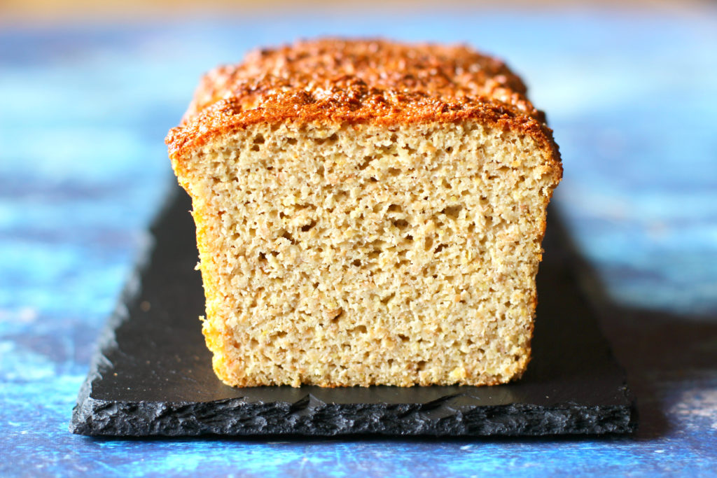

References:

- https://www.onlymyhealth.com/nine-types-of-bread-for-weight-loss-1445339581
- https://www.healthline.com/nutrition/healthiest-bread
- https://www.healthymummy.com/best-breads-lose-weight/
- https://www.healthline.com/nutrition/ezekiel-bread#TOC_TITLE_HDR_2
- https://universityhealthnews.com/daily/nutrition/low-carb-breads-that-wont-sabotage-your-diet/
- https://www.eatthis.com/10-best-brand-name-breads-weight-loss/
- https://www.tastingtable.com/cook/national/difference-between-sourdough-white-bread-video
- https://pubmed.ncbi.nlm.nih.gov/19781071/
- https://lpi.oregonstate.edu/mic/dietary-factors/phytochemicals/lignans
- https://www.ncbi.nlm.nih.gov/pmc/articles/PMC4152533/
- https://www.healthline.com/nutrition/whole-grain-vs-whole-wheat#:~:text=Both%20whole%20grain%20and%20whole%20wheat%20contain%20all%20three%20parts,barley%2C%20corn%2C%20and%20rye.

