8 Best Diet Plans In 2021

Though any journey, a thousand miles or not, always begins with a single step, when it comes to stepping into the diet world, it’s hard to know which foot to put forward.

Which is better: low cal or low carb?

Which is more sustainable: plant based or simply a whole food approach?

Maybe you’ve heard some buzz about fasting, is it something that would fit into your lifestyle, can it accommodate your nutritional needs?

The thing is, dieting isn’t a journey that can be entered with a one size fits all type of approach.

Every person’s body is different, and therefore the best diet for someone else may not be the best diet for you.

And, that’s why the best first step of any dieting journey begins with knowledge!

The more you know about a diet plan, the better prepared you are for success, being able to make the best choice for your lifestyle, your needs, and your personal goals.

So, here we’ll break down the basic information for 8 of the best diet plans and let you decide which path to choose...

1- Mediterranean

The mediterranean diet has topped the best diet charts for several years now.

It has been hailed as an easy to follow plan, the best diet for diabetes and heart health, and is often considered a best choice for dieting overall.

This diet focuses on the traditional foods and eating patterns of people living in the countries that surround the Mediterranean Sea.

On this plan, you are encouraged to eat fruits, vegetables, whole grains, nuts, and legumes daily, followed by weekly servings of fish, other seafood, as well as some poultry and eggs.

Red meat and sweets are permitted in smaller portions, less frequently, and processed foods are to be avoided altogether.

Consumption of healthy fats is encouraged, such as using olive oil in cooking as opposed to butter.

While most diets cut out specific groups of food, the mediterranean diet allows healthy foods from each and every food group, prioritizing those healthiest options, while still enjoying other foods, in smaller quantities.

Some would not consider this plan to be a weight loss diet, as adherence to a certain caloric goal is not required, though many do indeed report this style of eating to have been helpful as a means of losing weight.

2- Plant Based

A plant based diet is a diet that, just as it sounds, consists of eating primarily plant foods.

This style of eating focuses on consuming only whole foods derived from plants.

Some followers of a plant based diet will allow for the occasional meal containing eggs or poultry, but many strictly adhere to a plants only philosophy.

For those with weight loss as their primary goal, plant based diets prove to be successful as they are filled with foods high in fiber and low in calories and fat, as opposed to animal products.

These foods can be very satiating, keeping you feeling full longer, which also contributes to weight loss.

One version of a plant based diet that has gained popularity for its flexible nature is the flexitarian diet which is primarily plant based with the occasional allowance of animal products in moderation.

Plant based diets are also linked to a reduced risk of heart disease, some cancers, diabetes, and other chronic conditions.

3- WW

Described as the best diet plan for weight loss, WW (formerly known as Weight Watchers) has helped many achieve their weight loss goals.

Weight Watchers has been around for many years, but the newer program (WW), while still based on caloric restriction, primarily focuses on teaching followers of the plan to adopt healthy habits.

The plan’s calorie counting method is customized to your personal needs based on your age, weight, height, and sex. And, based on this information, each person is assigned a specific “smart points” goal for each day.

Every food and drink is assigned a smart points total, with saturated fats and sugar contributing to greater smart points values and protein-rich or whole, fresh foods contributing to lesser point values.

Then, through either the WW app or website, users track everything they eat and drink as well as their activity levels throughout the day.

The goal of the program is to direct users towards making healthier choices through the smart points system.

For example, users can earn points through being active. And, they can enjoy most fresh fruits and vegetables, as well as lean proteins for little to no points.

While no food is off limits, processed foods or those high in sugars and saturated fats possess greater point values, encouraging limited consumption of these less healthy options.

The result is a diet filled with greater amounts of healthy, whole foods, and fewer times where processed, high sugar, high fat foods are consumed as a way of life...of course, leading to weight loss and improved health.

4- Intermittent Fasting

Rather than focusing solely on what you do and do not eat, intermittent fasting focuses on when you do and do not eat.

Intermittent fasting involves restricting the time of day in which you are permitted to consume calories (food). This can mean an overall reduction in the number of calories one consumes, resulting in weight loss. But, this method boasts numerous other health benefits as well.

Intermittent fasting, also known as IF, is deemed safe for all adults and has been linked to improvements in brain health, reductions in inflammation, increases in insulin sensitivity, and boasts anti-aging effects as well.

Studies have shown IF to be effective at both weight loss and reducing waist circumference.

There are many ways to incorporate intermittent fasting, but some examples include the 16:8 method where one would fast for 16 hours (not consuming any food), then feed for 8 hours.

Some individuals incorporate entire 24 hours periods of fasting 1-2 times per week, followed by periods of normal eating on the other days in that week.

And, some individuals incorporate a similar method, where instead of completely abstaining from any caloric intake on those days, they consume a minimal amount of calories (500-600 or less) 2 days per week, while consuming a normal amount of calories the other 5 days in the week (often termed the 5:2 method).

While consuming whole, nutritious foods are encouraged during feeding times, intermittent fasting doesn’t restrict food groups or items as a whole.

5- Low Fat

Low fat diets do just what you’d expect from such a name, they restrict fat in your daily diet.

These diets often give a goal of only consuming 10-30% of your daily caloric intake from fats.

Compared to proteins and carbohydrates, fats account for twice the number of calories per gram, therefore, when restricting fat, you are essentially lowering your daily calorie intake as well, resulting in weight loss.

Research has shown that low fat diets can both reduce overall body weight and waist circumference.

In obese individuals, ultra low fat diets (reducing daily fat intake to 10% or less of their total calories) have proven most effective.

Low fat diets are associated with reductions in inflammation and a reduced risk of stroke and heart disease. However, these types of diets can also increase the risk of metabolic syndrome as fats are needed for hormone production, nutrient absorption, and the overall health of the cells in your body.

6- Low Carb

Low carb diets such as Atkins, keto, and low-carb-high-fat plans have gained much popularity due to their effectiveness in regards to weight loss specifically.

While some versions restrict your carbohydrate intake more than others, the basic premise of such diets is a reduction in carbs and a focus towards consuming proteins and fats.

Protein is key in these plans as both a satiating food and a means of raising your metabolism.

High fat/high protein (low carb) diets have been proven very successful at burning abdominal fat, and some low carb diets have been proven to reduce your risk of heart disease and diabetes, working to lower your blood pressure, cholesterol, and blood sugar levels.

While studies confirm that such diets are more effective at weight loss than traditional low-fat diets, they are often criticized for their lack of sustainability over time.

7- Paleo

The paleo diet gets its name from our paleolithic ancestors as the plan centers around consuming foods that were available to these people.
This means a strict plan focusing on consuming foods such as fruits, vegetables, meat, fish, poultry, and eggs. Nuts and seeds are permitted on the paleo diet, but these should only be consumed in moderation.

This also means a strict forbiddance to consuming any foods that wouldn’t have been available to our ancestors, such as grains, dairy, legumes, sugars, and salts...obviously, nothing processed.

This diet also demands physical exercise, a staple in the lives of our paleolithic ancestry.

Though the diet has proven successful for weight loss and a reduction in belly fat, the biggest criticism generally comes from the difficulty in adhering to this plan long term as it restricts several food groups (which many deem necessary nutritionally).

8- DASH

DASH stands for Dietary Approaches to Stop Hypertension. This style of eating is primarily a low sodium diet that aims to reduce blood pressure through diet, omitting the need for, or use of, prescription medication.

Fruits, vegetables, whole grains, lean meats, and low or nonfat dairy foods are encouraged, while consumption of saturated fats, red meat, salt, added sugars, and dietary cholesterol is limited or discouraged altogether.

Though not a weight loss plan per say, many followers report losing weight when following the DASH diet plan.

Daily recommendations regarding calorie intake determine how much a person consumes from each permitted food group per day, with an average person consuming 5 servings of fruit and vegetables, 7 servings of healthy carbs, 2 servings of low fat dairy, and less than 2 servings of lean meats daily.

This diet is associated with a reduced risk of depression, lowered blood pressure, a decreased risk of heart disease, and even a lowered risk of certain cancers.

Remember, each person is different, so be sure to choose a plan specific to your own needs and goals.

*Also, it is generally considered wise to consult with your physician before starting a new dietary plan, especially if you are currently taking medications or have any medical concerns or ailments.

DOWN 7 lbs in 3 days - “all I did was balance my hormones”

So a friend's mother (Debbie) ended up losing over 55 pounds in her mid-50's, and...

She credits it all to repairing her “female hormones” by following this simple 60-second trick.

I know it sounds weird, but the reason it works so well is because it naturally rebalances your 3 key hormones, estrogen, insulin, and cortisol.

Which are THE hormones that determine how much fat your body stores.

When these hormones are in balance… your body flips the switch on your metabolism.

Debbie lost 7 pounds in the first couple days... and NEVER gained it back

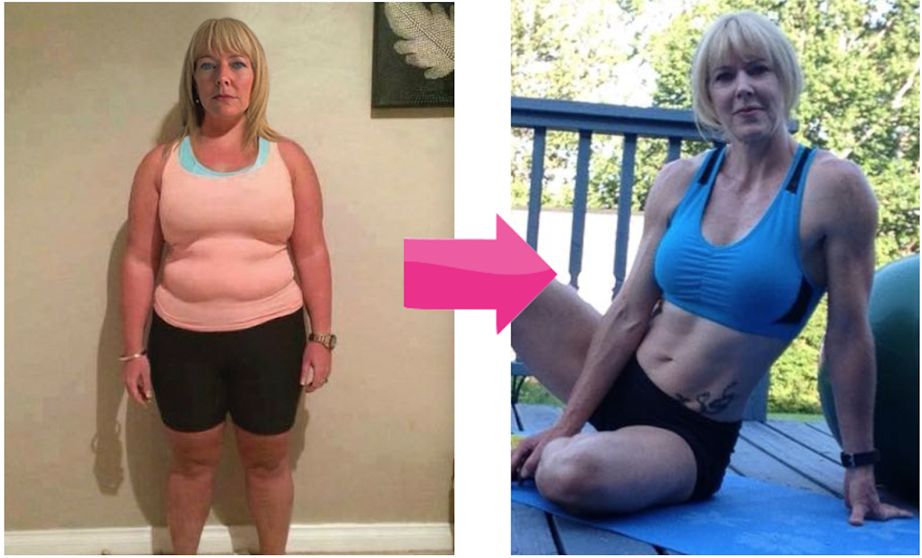

Do this Simple 30-sec routine to Flip the Switch on Your Metabolism

Hope this helps!

References:

- https://www.healthline.com/nutrition/best-diet-plans
- https://www.prevention.com/weight-loss/diets/g29462611/best-diets-weight-loss/
- https://www.eatingwell.com/article/7907497/things-i-wish-i-knew-before-trying-to-lose-weight/
- https://www.themediterraneandish.com/7-ways-follow-mediterranean-diet/
- https://www.usatoday.com/story/tech/reviewedcom/2020/01/29/ww-review-does-ww-weight-watchers-weight-loss-program-work/4611254002/
- https://www.everydayhealth.com/diet-nutrition/the-paleo-diet.aspx
- https://www.mayoclinic.org/healthy-lifestyle/nutrition-and-healthy-eating/in-depth/dash-diet/art-20048456

