

**(Please be sure swipe is named with Correct Date, List Initials, Vendor Name and Offer Name)

Notes for this send:

Notes for future sends:

Offer description:

Campaign Settings:

Brand - Naturely
From Name: Naturely
From Email: support@naturelyskincare.com
Reply Email: support@naturelyskincare.com
Lists To Send To:
In Jimmy we trust
Segments To Send To:
In Jimmy we trust
Suppress Lists:

Suppress Segments:

HTO Content Link Structure: https://talks.healthmeans.com/?talkid=XXXX

#1d3ceb

&subid2=
- NHN = 9
- 3XH = 12
- BHT = 13
- HTO = 14

&subid4=
- Campaign IDs -- unique for each send
- Use unique campaign ID for both CRC & HTO

Insert this in Custom HTML box in wordpress for article:
- <div style=“display:none;“>[uuid]</div>

For Article Links:
- ?uid=VAR_CUSTOMTAG_ID_45978_CVAR_CAMPAIGN_ID
- Important note: remove the / from the end of article links
For Affiliate Links within article:
- &aff_sub=[uuid, default=nhnXXX]
- &tid=[uuid, default=3xhXXX]
For Affiliate Links in Email Body:
- 3X Health Custom Var Tag:
  - VAR_CUSTOMTAG_ID_45978_CVAR_CAMPAIGN_ID

⟹
—
⇒
Blank space character inside => ( ‏‏‎ )

Content Link:

3XH Aff Link:
- https://trk.legendaff.com/aff_c?offer_id=67&aff_id=1506&aff_sub=VAR_CUSTOMTAG_ID_45978_CVAR_CAMPAIGN_ID

From: 3X Health
SL: bone on bone knee pain?
PH: Would you like your knees to go from this…

Body:

Would you like your knees to go from this:

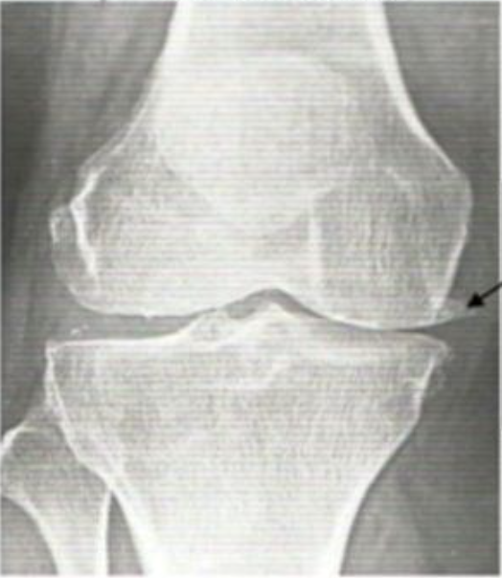

To this:

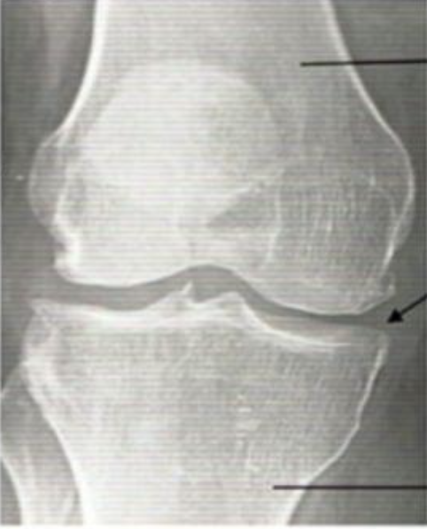

In as little as 30 days?

According to a recent study, there is a ONE compound that can do that, and it's shockingly affordable.

See what it is right here

To your health,
3X Health

