

**(Please be sure swipe is named with Correct Date, List Initials, Vendor Name and Offer Name)

Notes for this send:

Notes for future sends:

Offer description:

Campaign Settings:

Brand - Naturely
From Name: Naturely
From Email: support@naturelyskincare.com
Reply Email: support@naturelyskincare.com
Lists To Send To:
In Jimmy we trust
Segments To Send To:
In Jimmy we trust
Suppress Lists:

Suppress Segments:

HTO Content Link Structure: https://talks.healthmeans.com/?talkid=XXXX

#1d3ceb

&subid2=
- NHN = 9
- 3XH = 12
- BHT = 13
- HTO = 14

&subid4=
- Campaign IDs -- unique for each send
- Use unique campaign ID for both CRC & HTO

Insert this in Custom HTML box in wordpress for article:
- <div style=“display:none;“>[uuid]</div>

For Article Links:
- ?uid=VAR_CUSTOMTAG_ID_45978_CVAR_CAMPAIGN_ID
- Important note: remove the / from the end of article links
For Affiliate Links within article:
- &aff_sub=[uuid, default=nhnXXX]
- &tid=[uuid, default=3xhXXX]
For Affiliate Links in Email Body:
- 3X Health Custom Var Tag:
  - VAR_CUSTOMTAG_ID_45978_CVAR_CAMPAIGN_ID

⟹
—
⇒
Blank space character inside => ( ‏‏‎ )

Content Link:

3XH Aff Link:
- https://trk.legendaff.com/aff_c?offer_id=84&aff_id=1506&aff_sub=VAR_CUSTOMTAG_ID_45978_CVAR_CAMPAIGN_ID

From: your skinny friend – 3X Health
SL: eat this to burn off 40% more calories (without exercise)
PH: what if you could eat all your favorite foods and still lose weight?

Body:

Carbs and sweets are what make you gain weight...

Right?

Well, that's what the experts keep telling us, anyway...

But what if you could eat all your favorite foods and still lose weight?

Latest studies may have finally found a way…

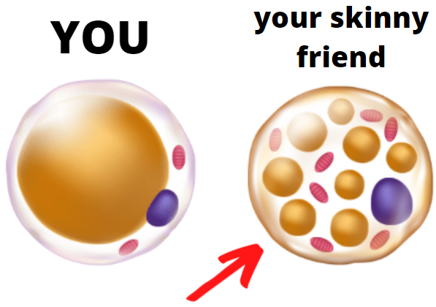

REVEALED: The secret behind your skinny friend’s fast metabolism

To your health,
3X Health

