

**(Please be sure swipe is named with Correct Date, List Initials, Vendor Name and Offer Name)

Notes for this send:

Notes for future sends:

Offer description:

Campaign Settings:

Brand - Naturely
From Name: Naturely
From Email: support@naturelyskincare.com
Reply Email: support@naturelyskincare.com
Lists To Send To:
In Jimmy we trust
Segments To Send To:
In Jimmy we trust
Suppress Lists:

Suppress Segments:

HTO Content Link Structure: https://talks.healthmeans.com/?talkid=XXXX

#1d3ceb

&subid2=
- NHN = 9
- 3XH = 12
- BHT = 13
- HTO = 14

&subid4=
- Campaign IDs -- unique for each send
- Use unique campaign ID for both CRC & HTO

Insert this in Custom HTML box in wordpress for article:
- <div style=“display:none;“>[uuid]</div>

For Article Links:
- ?uid=VAR_CUSTOMTAG_ID_45978_CVAR_CAMPAIGN_ID
- Important note: remove the / from the end of article links
For Affiliate Links within article:
- &aff_sub=[uuid, default=nhnXXX]
- &tid=[uuid, default=3xhXXX]
For Affiliate Links in Email Body:
- 3X Health Custom Var Tag:
  - VAR_CUSTOMTAG_ID_45978_CVAR_CAMPAIGN_ID

⟹
—
⇒
Blank space character inside => ( ‏‏‎ )

Content Link:

3XH Aff Link:
- https://hop.clickbank.net/?affiliate=crcco&vendor=beyond40s&vsl=1&tid=VAR_CUSTOMTAG_ID_45978_CVAR_CAMPAIGN_ID

From: Down 31 - 3X Health
SL: Grandma lost 31LBs doing this ONE thing every day [pic]
PH: All this 60-year-old grandma did to lose 11lbs of stuck belly fat in just 7 days…

Body:

All this 60-year-old grandma did to lose 11lbs of stuck belly fat in just 7 days, was use this ONE 10 second fat-burning trick every day—right from the comfort of her own home...
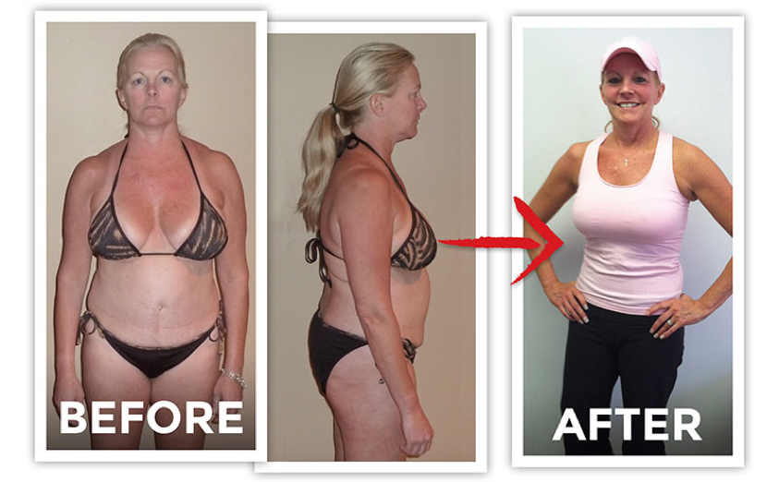

She didn’t spend a second exercising…

She still ate all her favorite carbs and cheat foods…

And right now, for the first time ever, this grandma is sharing her secret…

All you have to do is wake up, add THIS to your daily regimen, and you’ll instantly SEE your belly get flatter each day…

Over 252,334 regular folks, just like you, have already used this missing piece of the weight-loss puzzle to effortlessly increase their belly fat-burning capacity up to 400%.

Now it’s your turn:

Go here and discover her 10-second weight loss secret

To your health!
3X Health

P.S. Imagine finally getting rid of that excess weight…and FAST. See the Before and After Photos Here.

