

**(Please be sure swipe is named with Correct Date, List Initials, Vendor Name and Offer Name)

Notes for this send:

Notes for future sends:

Offer description:

Campaign Settings:

Brand - Naturely
From Name: Naturely
From Email: support@naturelyskincare.com
Reply Email: support@naturelyskincare.com
Lists To Send To:
In Jimmy we trust
Segments To Send To:
In Jimmy we trust
Suppress Lists:

Suppress Segments:

HTO Content Link Structure: https://talks.healthmeans.com/?talkid=XXXX

#1d3ceb

&subid2=
- NHN = 9
- 3XH = 12
- BHT = 13
- HTO = 14

&subid4=
- Campaign IDs -- unique for each send
- Use unique campaign ID for both CRC & HTO

Insert this in Custom HTML box in wordpress for article:
- <div style=“display:none;“>[uuid]</div>

For Article Links:
- ?uid=VAR_CUSTOMTAG_ID_45978_CVAR_CAMPAIGN_ID
- Important note: remove the / from the end of article links
For Affiliate Links within article:
- &aff_sub=[uuid, default=nhnXXX]
- &tid=[uuid, default=3xhXXX]
For Affiliate Links in Email Body:
- 3X Health Custom Var Tag:
  - VAR_CUSTOMTAG_ID_45978_CVAR_CAMPAIGN_ID

⟹
—
⇒
Blank space character inside => ( ‏‏‎ )

Content Link:

3XH Aff Link:
- https://hop.clickbank.net/?vendor=painfix&affiliate=crcco&tid=VAR_CUSTOMTAG_ID_45978_CVAR_CAMPAIGN_ID

From: 3X Health
SL: #1 muscle that eliminates joint and back pain, anxiety and looking fat
PH: It’s kind of crazy… This muscle RULES what ails most people…

Body:

I bet you can’t guess which muscle in your body is the #1 muscle that eliminates joint and back pain, anxiety and looking fat.

This “hidden survival muscle” in your body will boost your energy levels, immune system, sexual function, strength and athletic performance when unlocked.

If this “hidden” most powerful primal muscle is healthy, we are healthy.

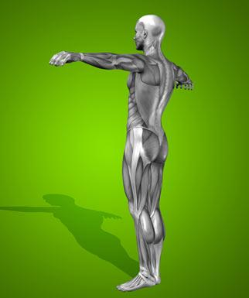

Is it…

a) Abs

b) Chest

c) Glutes

d) Hip Flexors

Take the quiz above and see if you got the correct answer!

To your health,
3X Health

P.S. Make sure you check out the next page to get to know the 10 simple moves that will bring vitality back into your life!

==> Click here to discover which “hidden survival muscle” will help you boost your energy levels, immune system, sexual function, strength and athletic performance permanently!

