

**(Please be sure swipe is named with Correct Date, List Initials, Vendor Name and Offer Name)

Notes for this send:

Notes for future sends:

Offer description:

Campaign Settings:

Brand - Naturely
From Name: Naturely
From Email: support@naturelyskincare.com
Reply Email: support@naturelyskincare.com
Lists To Send To:
In Jimmy we trust
Segments To Send To:
In Jimmy we trust
Suppress Lists:

Suppress Segments:

HTO Content Link Structure: https://talks.healthmeans.com/?talkid=XXXX

#1d3ceb

&subid2=
- NHN = 9
- 3XH = 12
- BHT = 13
- HTO = 14

&subid4=
- Campaign IDs -- unique for each send
- Use unique campaign ID for both CRC & HTO

Insert this in Custom HTML box in wordpress for article:
- <div style=“display:none;“>[uuid]</div>

For Article Links:
- ?uid=VAR_CUSTOMTAG_ID_45978_CVAR_CAMPAIGN_ID
- Important note: remove the / from the end of article links
For Affiliate Links within article:
- &aff_sub=[uuid, default=nhnXXX]
- &tid=[uuid, default=3xhXXX]
For Affiliate Links in Email Body:
- 3X Health Custom Var Tag:
  - VAR_CUSTOMTAG_ID_45978_CVAR_CAMPAIGN_ID

⟹
—
⇒
Blank space character inside => ( ‏‏‎ )

Content Link:

3XH Aff Link:
- https://hop.clickbank.net/?affiliate=crcco&vendor=criticalb&tid=VAR_CUSTOMTAG_ID_45978_CVAR_CAMPAIGN_ID

From: home balance test - 3X Health
SL: Quick At-home Test Reveals The Truth About Your Balance
PH: find out if your balance is older than your age

Body:

Did you know there’s a simple 10-second test you can do at home to find out if your balance is older than your age?

This balance test was first uncovered by a Harvard Ph.D.…

All you need to do is sit down in a chair, move your leg like THIS for 10 seconds, and watch how it feels.

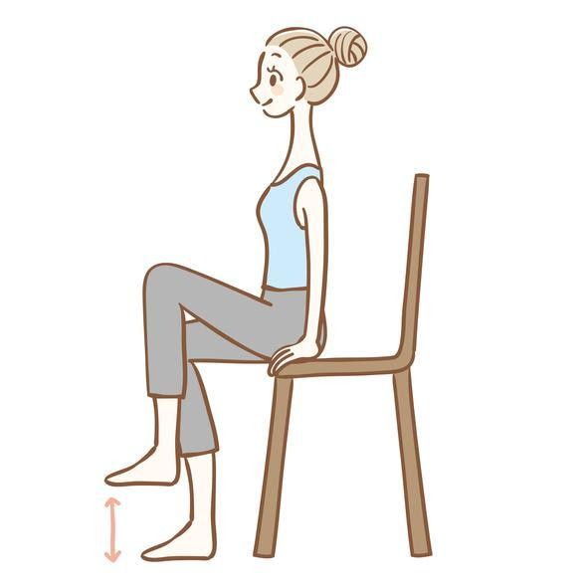

This is important news.

If you or someone you love are suffering from serious balance problems and a fear of falling…

You need to take this balance test immediately and find out your balance score.

Click here now to take the test and find out what you can do to improve your balance.

