

**(Please be sure swipe is named with Correct Date, List Initials, Vendor Name and Offer Name)

Notes for this send:

Notes for future sends:

Offer description:

Campaign Settings:

Brand - Naturely
From Name: Naturely
From Email: support@naturelyskincare.com
Reply Email: support@naturelyskincare.com
Lists To Send To:
In Jimmy we trust
Segments To Send To:
In Jimmy we trust
Suppress Lists:

Suppress Segments:

HTO Content Link Structure: https://talks.healthmeans.com/?talkid=XXXX

#1d3ceb

&subid2=
- NHN = 9
- 3XH = 12
- BHT = 13
- HTO = 14

&subid4=
- Campaign IDs -- unique for each send
- Use unique campaign ID for both CRC & HTO

Insert this in Custom HTML box in wordpress for article:
- <div style=“display:none;“>[uuid]</div>

For Article Links:
- ?uid=VAR_CUSTOMTAG_ID_45978_CVAR_CAMPAIGN_ID
- Important note: remove the / from the end of article links
For Affiliate Links within article:
- &aff_sub=[uuid, default=nhnXXX]
- &tid=[uuid, default=3xhXXX]
For Affiliate Links in Email Body:
- 3X Health Custom Var Tag:
  - VAR_CUSTOMTAG_ID_45978_CVAR_CAMPAIGN_ID

⟹
—
⇒
Blank space character inside => ( ‏‏‎ )

Content Link:
- https://3xhealth.com/swimming-a-host-of-health-benefits-you-may-not-be-aware-of?uid=VAR_CUSTOMTAG_ID_45978_CVAR_CAMPAIGN_ID

3XH Aff Link:
- http://tracking.bioleptin.net/aff_c?offer_id=64&aff_id=3243&aff_sub=VAR_CUSTOMTAG_ID_45978_CVAR_CAMPAIGN_ID

From: 3X Health
SL: Swimming… A Host of Health Benefits
PH: Can this powerful nutrient really kill all cravings?
ALT PH: Eat less and always feel full
ALT PH: Weight loss aid that makes your tummy full with less food

Body:

Today’s featured health article => Swimming: A Host Of Health Benefits You May Not Be Aware Of

Can this powerful nutrient really kill all cravings?
People struggling with overeating, cravings, and obesity now have a new option to help them manage how much they eat.
It's called Irvingia Gabonensis and it could be the miracle that finally allows people to lose weight without the dieting or exercise routines.
In a recent study people on average lost a whopping 28.1lbs, reduced overall body fat by 18.4% (that's a FIFTH of your body fat. GONE) and watched in amazement as their waist size shrank by 6.7"!
Those are pretty incredible results right?
So how do you get it?
Well, getting pure Irvingia Gabonensis can be pretty tough and expensive.
But there is a supplement on the market that uses this nutrient as its main ingredient.
It's called BioLeptin and when people take it, they notice almost immediately that their appetite is suppressed and the pounds start melting off almost right away.
Just like it did for Jeffrey who lost 20lbs in 2 weeks!
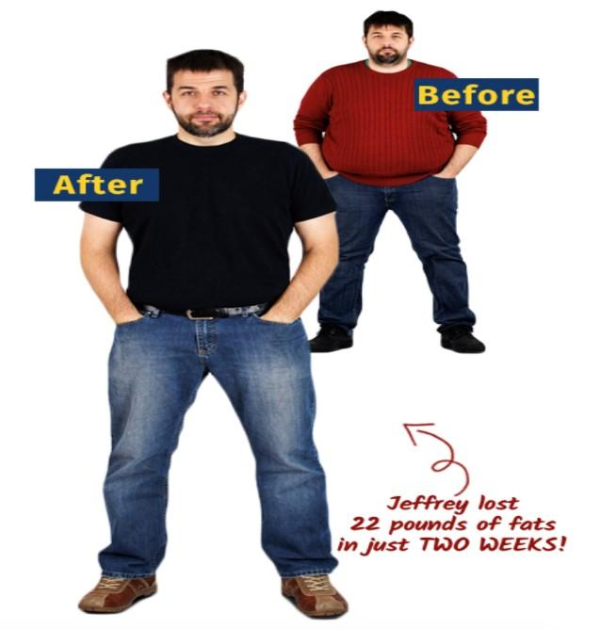
Now, not everyone is going to have the exact same results, but what would it mean to you if you could lose 5, 10 or just 15 pounds in the next few weeks?
Then think about what the next few months might bring!
If you'd like to try it, click here now.

To your health,
3X Health

