

**(Please be sure swipe is named with Correct Date, List Initials, Vendor Name and Offer Name)

Notes for this send:

Notes for future sends:

Offer description:

Campaign Settings:

Brand - Naturely
From Name: Naturely
From Email: support@naturelyskincare.com
Reply Email: support@naturelyskincare.com
Lists To Send To:
In Jimmy we trust
Segments To Send To:
In Jimmy we trust
Suppress Lists:

Suppress Segments:

HTO Content Link Structure: https://talks.healthmeans.com/?talkid=XXXX

#1d3ceb

&subid2=
- NHN = 9
- 3XH = 12
- BHT = 13
- HTO = 14

&subid4=
- Campaign IDs -- unique for each send
- Use unique campaign ID for both CRC & HTO

Insert this in Custom HTML box in wordpress for article:
- <div style=“display:none;“>[uuid]</div>

For Article Links:
- ?uid=VAR_CUSTOMTAG_ID_45978_CVAR_CAMPAIGN_ID
- Important note: remove the / from the end of article links
For Affiliate Links within article:
- &aff_sub=[uuid, default=nhnXXX]
- &tid=[uuid, default=3xhXXX]
For Affiliate Links in Email Body:
- 3X Health Custom Var Tag:
  - VAR_CUSTOMTAG_ID_45978_CVAR_CAMPAIGN_ID

⟹
—
⇒
Blank space character inside => ( ‏‏‎ )

Content Link:
- https://betterhealthtrends.com/2021/03/03/mighty-miraculous-moringa-the-plant-that-could-potentially-combat-everything-from-corona-to-chronic-illness?uid=VAR_CUSTOMTAG_ID_45978_CVAR_CAMPAIGN_ID

3XH Aff Link:
- https://www.nos20trk.com/cmp/6W8G5Q/49747C/?sub1=VAR_CUSTOMTAG_ID_45978_CVAR_CAMPAIGN_ID

From: 3X Health
SL: Immunity Super Nutrient? (featured article)
PH: Then there are times when a substance comes to light, and it truly astounds us

Body:

Today’s featured health article => Immunity Super Nutrient Often Referred To As The Miracle Tree

Natural products chemist, Carrie Waterman, of the University of California, has said “if there were a top 10 list of plants that are going to help feed the world over the next hundred years, I would say moringa should be on that list.”

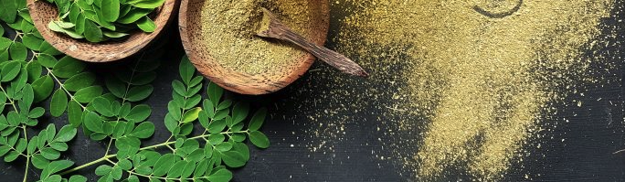

Energy down in the dumps? try THIS for free

My good friend, Cody got so excited after discovering all the fat loss and energy boosting benefits of Moringa…

That he accidentally ordered way more containers of Moringa than he needed.

Now they are taking up a huge space in his small business warehouse…

So he has decided to give them for FREE to our loyal email readers…

Which means YOU.

If you didn’t know, Moringa is literally nature's medicine and one of the often overlooked superfoods…

It includes 7 times more vitamin C than an orange…

And also has 14 times more potassium than a banana…

Which means it can help you take back the control of your stress, sleep and energy while helping you shed excess pounds.

Now to get these Moringa bottles for FREE, all you have to do is just click the link below:

→ Get 4 Bottles of Moringa For FREE Here (worth $196)

Please note this email is going out to my list of 14,871 people and Cody only has 197 more bottles to give…

So if you want to get them before they go out of stock, click the link below:

→ Get 4 Bottles of Moringa For FREE Here (worth $196)

To your health,
3X Health

