

**(Please be sure swipe is named with Correct Date, List Initials, Vendor Name and Offer Name)

Notes for this send:

Notes for future sends:

Offer description:

Campaign Settings:

Brand - Naturely
From Name: Naturely
From Email: support@naturelyskincare.com
Reply Email: support@naturelyskincare.com
Lists To Send To:
In Jimmy we trust
Segments To Send To:
In Jimmy we trust
Suppress Lists:

Suppress Segments:

HTO Content Link Structure: https://talks.healthmeans.com/?talkid=XXXX

#1d3ceb

&subid2=
- NHN = 9
- 3XH = 12
- BHT = 13
- HTO = 14

&subid4=
- Campaign IDs -- unique for each send
- Use unique campaign ID for both CRC & HTO

Insert this in Custom HTML box in wordpress for article:
- <div style=“display:none;“>[uuid]</div>

For Article Links:
- ?uid=VAR_CUSTOMTAG_ID_45978_CVAR_CAMPAIGN_ID
- Important note: remove the / from the end of article links
For Affiliate Links within article:
- &aff_sub=[uuid, default=nhnXXX]
- &tid=[uuid, default=3xhXXX]
For Affiliate Links in Email Body:
- 3X Health Custom Var Tag:
  - VAR_CUSTOMTAG_ID_45978_CVAR_CAMPAIGN_ID

⟹
—
⇒
Blank space character inside => ( ‏‏‎ )

Content Link:
- https://3xhealth.com/you-can-burn-fat-and-build-muscle-simultaneously-fact-or-fiction?uid=VAR_CUSTOMTAG_ID_45978_CVAR_CAMPAIGN_ID

3XH Aff Link:
- https://hop.clickbank.net/?affiliate=crcco&vendor=lbjuice&pid=30&tid=VAR_CUSTOMTAG_ID_45978_CVAR_CAMPAIGN_ID

From: 3X Health
SL: Can Burn Fat And Build Muscle Simultaneously? (Article)
PH: fizzy morning juice melts 3LBs every 4 days?

Body:

Today’s featured health article => You Can Burn Fat And Build Muscle Simultaneously: Fact Or Fiction?

Fizzy morning juice melts 3LBs every 4 days?

I recently stumbled on a powerful fat-busting juice that I simply have to share with you…

>> Fizzy juice melts 62 LBs of thick fat

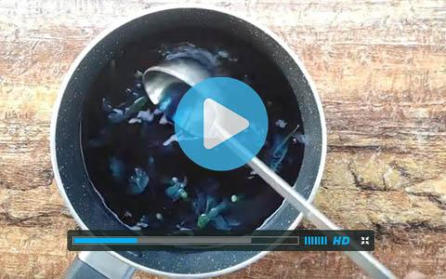

When you guzzle down this potent juice for yourself….

Do it before breakfast…

Because when you do, you melt through more fat than 3 months on a restrictive fad diet..

The longest-living people on the planet drink it each morning…

67,418 Americans have now used it to drop anywhere between 10LBs and 91LBs…

And the reason it’s so powerful…

Is all down to ONE potent ingredient proven to target and dissolve the clogged fat from around your organs…

Try it for yourself when you wake up tomorrow:

>> Powerful juice “eats through” 10-100LBs of fat

To your good health.

NAME

PS. It’s proven by doctors to be the best and safest way to “dislodge” clogged fat and flush it straight out….freeing up your metabolism, energy and sex drive, at any age:

>> Juice ingredient melts through 62LBs of clogged flab

To your health,
3X Health

