

**(Please be sure swipe is named with Correct Date, List Initials, Vendor Name and Offer Name)

Notes for this send:

Notes for future sends:

Offer description:

Campaign Settings:

Brand - Naturely
From Name: Naturely
From Email: support@naturelyskincare.com
Reply Email: support@naturelyskincare.com
Lists To Send To:
In Jimmy we trust
Segments To Send To:
In Jimmy we trust
Suppress Lists:

Suppress Segments:

HTO Content Link Structure: https://talks.healthmeans.com/?talkid=XXXX

#1d3ceb

&subid2=
- NHN = 9
- 3XH = 12
- BHT = 13
- HTO = 14

&subid4=
- Campaign IDs -- unique for each send
- Use unique campaign ID for both CRC & HTO

Insert this in Custom HTML box in wordpress for article:
- <div style=“display:none;“>[uuid]</div>

For Article Links:
- ?uid=VAR_CUSTOMTAG_ID_45978_CVAR_CAMPAIGN_ID
- Important note: remove the / from the end of article links
For Affiliate Links within article:
- &aff_sub=[uuid, default=nhnXXX]
- &tid=[uuid, default=3xhXXX]
For Affiliate Links in Email Body:
- 3X Health Custom Var Tag:
  - VAR_CUSTOMTAG_ID_45978_CVAR_CAMPAIGN_ID

⟹
—
⇒
Blank space character inside => ( ‏‏‎ )

Content Link:
- https://betterhealthtrends.com/2021/02/03/most-effective-intermittent-fasting-methods-for-weight-loss?uid=VAR_CUSTOMTAG_ID_45978_CVAR_CAMPAIGN_ID

3XH Aff Link:
- https://hop.clickbank.net/?affiliate=crcco&vendor=slimcrysta&op=watervsl&tid=VAR_CUSTOMTAG_ID_45978_CVAR_CAMPAIGN_ID

From: 3X Health
SL: Most Effective Intermittent Fasting Methods For Weight Loss
PH: She Lost 82Ibs While On Heart Meds

Body:

Today’s featured health article => Most Effective Intermittent Fasting Methods For Weight Loss

She Lost 82Ibs While On Heart Meds

You can lose a lot of weight even if you are on heart meds.

Georgia who’s 57, did it while being on Zocor (and also going through menopause).

Read her story below so you get inspired and have an amazing rest of the day!

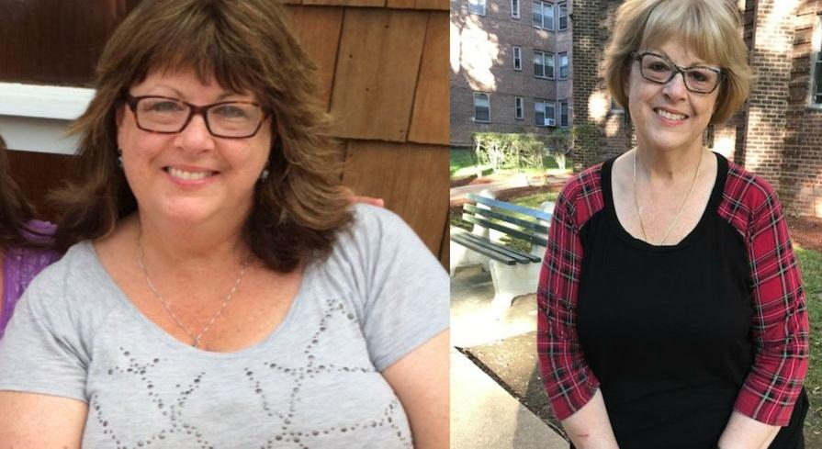

"Hi, I'm Georgia, and I'm a 57 years young grandmother living in California…

And I am sharing my story because I am so proud and full of gratitude for the fact that I was able to lose 82Ibs… while on heart meds, as I was taking Zocor when I started.

The truth is that I’ve been thin only when I was little.

My parents, who were both overweight, got really sick because of it…

My mother had heart problems and my father was diabetic and they both died before they reached their 65th birthday.
So, I saw with my own eyes what it meant to be fat…
After I turned 40, my nightmare started, as I began to feel the effects of a body that was getting older.
I have always been a busy mother who worked over 60 hours a week and also took care of my family…

So, I didn't have any time to exercise or be active other than doing laundry or cleaning the house.
Before long, I realized that I was following my parents’ footsteps as my weight kept increasing every year…

I entered menopause in the end of 2019 and with the “help” of the pandemic, I got to over 220 pounds.

My health was going downhill…

With both my sister and my daughter being over 50 pounds overweight...

And since I didn't want to end up like my parents and I was feeling sluggish all the time…

I decided to do my annual doctor checkup as I missed it in the past year… and get some guidance.

There, I found out my blood pressure and cholesterol levels were so high that my doctor told me that I may have developed the same heart problems as my mother…

So, he prescribed blood pressure pills, namely Zocor.

He also told me that I needed to lose weight immediately!

It was no longer just about my low self-esteem and lack of energy, it was about my life, so I started praying for a solution.
The truth is I tried losing weight in the past… tried Weight Watchers, followed by the Cambridge Diet, the Liquid Diet, Jenny Craig, and more… but nothing worked!

So, I was skeptical each time I heard of a new plan because they all promise you results, but don’t deliver anything!

But I was losing a little bit of self-esteem every single day… and I hated myself for how fat I was.

Each time I had to buy clothes I was feeling even more miserable and a complete lack of confidence in myself as I felt how people stared at me.

So, I would have given anything to find something that worked.
My hair dresser told me that she had already lost 23Ibs by drinking Slimcrystal water, a new type of water discovered by a group of water scientists…

But I didn’t believe her!
However, one Sunday evening, I was scrolling through Facebook and I found a video with a 59 years old overweight woman, who, by drinking the same Slimcrystal water…

Had lost 19Ibs in 3 months and was filled with energy.
Somehow, she gave me the confidence to get the water’s recipe and start drinking it too.

Go Here and Get Slimcrystal Water’s Recipe So You Can Lose Weight Naturally!

I also shared the recipe with my doctor and he said I can start drinking it.

I was in such bad shape then that just going up the stairs in my own house took my breath away…

My husband laughed at me when I started drinking Slimcrystal water…

But after just a few days, when he saw how much more energy I had, he started drinking it too because he also liked the mild pleasant taste it had.
In 30 days, miraculously, I lost 8 pounds.
Seeing that something is finally working, I decided to eat healthier and I started to walk for 15 minutes every 2 evenings.

Since then, I lost an additional 74Ibs and my doctor was so amazed that he took me off Zocor.

Go Here and Get Slimcrystal’s Water Recipe So You Can Lose Weight Naturally!

I finally can live my life again without worrying daily about my health.

I wake up every single morning, filled with energy and enthusiasm for the day ahead!

Even my sister and my daughter started drinking Slimcrystal water and they are both losing weight and feeling happier and healthier.

I am healthy and I feel at least 20 years younger!

I can now play with my grandkid for hours without pain or fatigue, just as if I was a child his own age.

I know that if I hadn’t found out about Slimcrystal water, I would still be battling with heart disease…

That’s why I strongly feel that everyone should start drinking Slimcrystal water because it truly helped me change my life!”

Go Here and Get Slimcrystal’s Water Recipe So You Can Lose Weight Naturally!

