RSG Re-direct Link:

CRC Link: https://hop.clickbank.net/?affiliate=AFFID&vendor=resurge&tid=postreg01

Note: After 15 seconds the post optin page below is re-directed to a VSL offer. Previously this was to the Resurge weight loss offer.
An example of how the post optin page should work can be view by opting for the free report at the following link: https://aff.transformationinsider.com/aff_c?offer_id=63&aff_id=1189&source=TRACKINGID&aff_sub5=%7b%7bcontact.email%7d%7d

Post Opt-In Page:
FREE Video Bonus!

Thank you! Your free report will be delivered in the next hour.

The following free bonus presentation reveals how one tiny, 2-minute change to your after-dinner routine burns belly fat while you SLEEP.

The free presentation is loading!

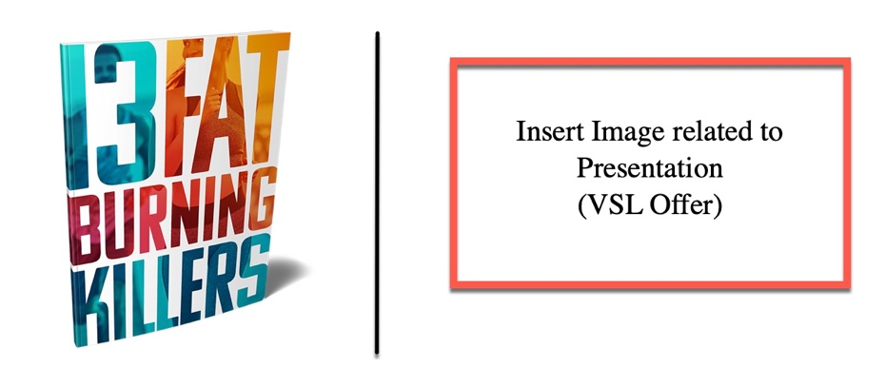

Loading...

EXAMPLE PAGE:

